|  |
| --- |
| TEAM MEMBERS   1. PREETHI.R -410121243042 2. SARMILA.A -410121243052 3. SHAGUFTHA.K -410121243053 4. SUBASHINI.M -410121243056 5. SUSHMA.R -410121243057 |



BOOK A DOCTOR USING MERN

BOOK A DOCTOR USING MERN

Abstract:

The "Book a Doctor" project is a healthcare management system designed to simplify the process of booking medical appointments. Using the MERN (MongoDB, Express.js, React, Node.js) stack and a "Healthcare Management System" dataset from Kaggle, this project enables efficient patient-doctor interactions, appointment scheduling, and basic billing functionalities. The system's purpose is to streamline appointment booking, improve accessibility to medical services, and ensure easy data management for both patients and healthcare providers. This project incorporates various technologies to create a user-friendly and scalable platform, enabling future advancements in telemedicine.

Introduction:

With the increasing demand for accessible healthcare, digital solutions that enable patients to schedule appointments with doctors are essential. The "Book a Doctor" system is a full-stack web application that leverages the MERN stack to create a seamless experience for patients seeking medical care. The system integrates essential features, such as patient registration, doctor profiles, appointment scheduling, and billing information, allowing healthcare facilities to manage interactions efficiently. The project aims to reduce wait times, increase patient satisfaction, and provide a user-friendly interface that makes healthcare more accessible to everyone.

Architecture (Block Diagram):

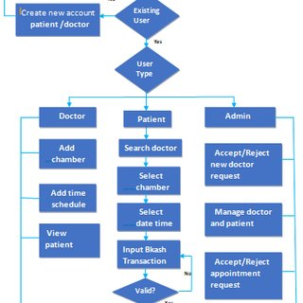

Here’s the architecture block diagram for your "Book a Doctor" application using the MERN stack. This layout includes layers for the frontend (React), backend (Node.js and Express), database (MongoDB), and an optional external client layer for potential integrations with other healthcare services

Future Enhancement:

In the future, "Book a Doctor" could integrate additional features to enhance the healthcare experience:

* **Teleconsultation**: Video conferencing capabilities for remote consultations.
* **AI-Powered Doctor Recommendation**: Suggest doctors based on patient history and preferences using machine learning.
* **Enhanced Billing and Insurance Integration**: Allow for detailed billing, insurance claim submission, and payment processing.
* **Patient Health Record Management**: Incorporate Electronic Health Records (EHR) to store and retrieve patient medical histories securely.
* **Feedback and Rating System**: Allow patients to rate doctors and provide feedback, enabling a higher quality of service.

These future enhancements can make "Book a Doctor" a comprehensive platform for digital healthcare services.

Conclusion:

The "Book a Doctor" project provides a powerful yet user-friendly solution for healthcare appointment management. Built with the MERN stack, this system facilitates seamless communication between patients and healthcare providers. By streamlining the appointment booking and billing processes, "Book a Doctor" empowers patients with better healthcare access and equips medical professionals with a reliable platform for managing interactions. With potential enhancements in telemedicine and AI integration, "Book a Doctor" can further transform the way patients and doctors connect, promoting more efficient and accessible healthcare for all.